SCENARIO - Cyclone
The Tech team anticipates higher Sea Surface Temperature (SST) anomalies in the months of May and June, in the Arabian sea particularly north eastern region; thus, indicating higher probabilities of cyclonic conditions in the year 2025. The evolving La Niña conditions are driving warmer-than-average SSTs, with anomalies ranging between 2–4°C. This substantial warming, low vertical wind shear provides a conducive environment for cyclonic activity. The elevated SSTs not only energize potential cyclonic systems but also prolong their lifespan, allowing them to gain strength as they traverse the Arabian Sea. Historical patterns suggest that El Niño years correlate with an increased frequency and intensity of tropical cyclones in the region. This anomaly is expected to amplify the probability of Severe Cyclonic Storms (Category 3 or higher) forming and intensifying near Pakistan's coastline.
Disaster Early Warning Notification
Issued Date: March 20
Validity Period: May – June
Indicators & Monitoring
Sea Surface Temperature (SST): Significant increase observed.
Upper-Level Divergence: Higher than normal.
Vertical Wind Shear: Low, favourable for cyclone formation.
Forecast & Possible Impact
A cyclonic circulation is likely to form in June/July. The cyclone may follow two possible trajectories, details to be refined with further monitoring.
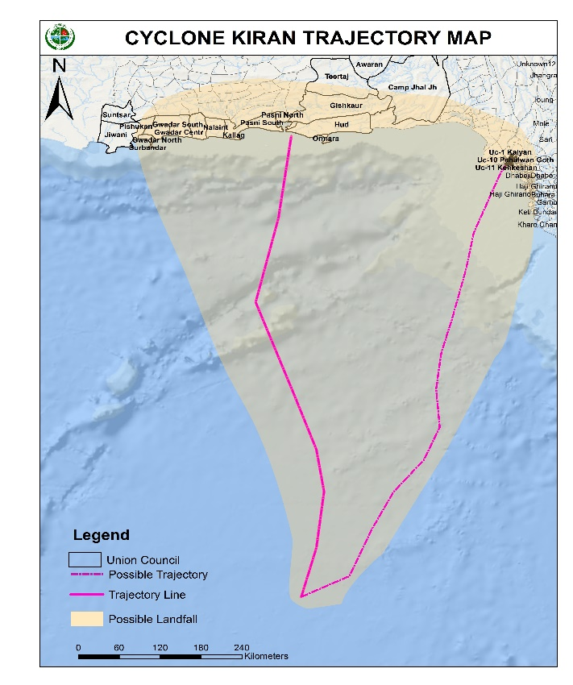

Cyclone Kiran

Alert | Date | System Status | Location | Wind Gusts | Key Details
A | 27th June | Low-Pressure System (LPS) | 750 km from Karachi | - | Expected to strengthen into a Tropical Depression by 28 June.
B | 28th June | Tropical Depression (TD) | 692 km from Karachi | 70–80 km/h | Trajectory towards Sindh coast; likely to become a storm system.
C | 29th June | Tropical Storm System (TSS) | 600 km from Karachi | 100 km/h | Likely to intensify into a Category 1 cyclone; named "Kiran."
D | 30th June | Category 1 Cyclone (Kiran) | 490 km southwest of Thatta | 130 km/h | Expected to strengthen into a Category 2 cyclone.
E | 1July | Category 2 Severe Cyclone (Kiran) | 300 km southwest of Thatta | 155 km/h | Likely to intensify into a Category 3 cyclone.
F | 2nd July | Category 3 Extremely Severe Cyclone (Kiran) | 178 km southwest of Karachi | 180 km/h | Reached peak intensity; expected to weaken to Category 2 at landfall on 3rd July near Karachi
G | 3rd July | Category 2 Cyclone (Kiran) | Near Karachi (landfall expected) | 160 km/h | Landfall expected; 77,743 exposed in immediate zone; ~972,501 affected in the wider region.

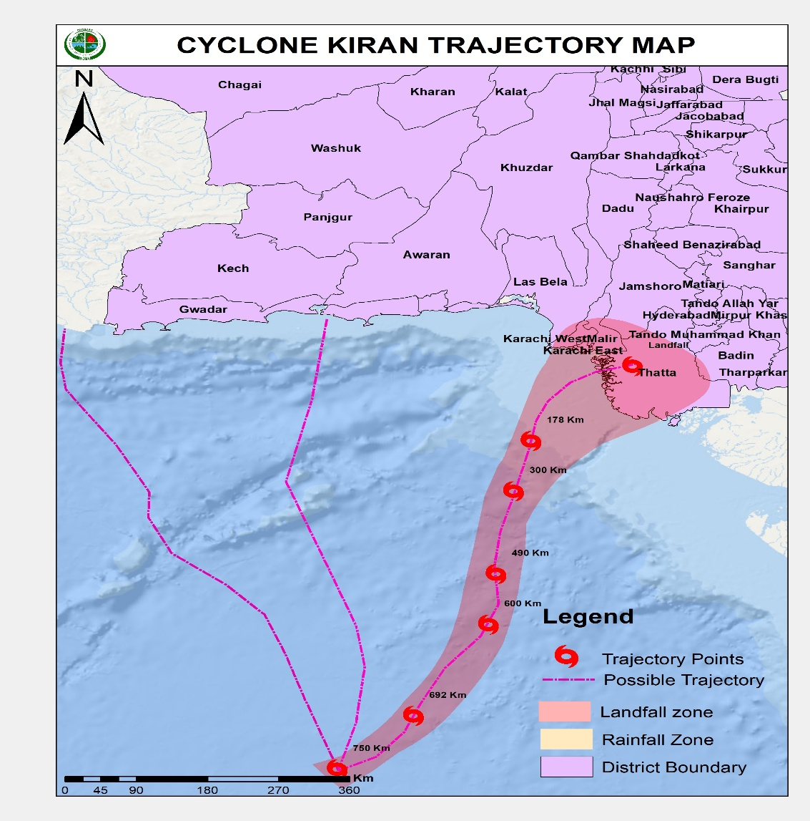

ARC Exposure
